VISER Co.,Ltd. ((주)바이저)
President | Mi-Ran Song | Establishment | April 9, 2004
Marketing Manager | Jae-Soun Jo | Business Type | Rubber products  Manufacturing
Mobile No. | 82-01-5176-0441 | Fax. | 82-55-346-0841
Office No. | 82-70-8611-3262 | Fax. | 82-55-346-0841
E-Mail | fromsue@viser.co.kr | Homepage | www.viser.co.kr
Address | #432-1 Shincheon-ri Hanlim-myeon Gimhae GyeongSangNam-do  South Korea 621873
Main  Products | - PHE Gaskets(Maximum gasket size 3,700(L)mm*1,400(W)mm)  - Rubber lining for corrosion prevention  -Distance Ring/Rubber Spool/Blind pad  - Rubber products for Special purposes (custom-made rubber products for shipbuilding industry and others)  - After-sales service (A/S) Market  - We can produce almost all kinds of PHE Gaskets. We also offer the best possible after-sale service to you even though your existing gaskets are fabricated by other companies around the world.  - Usable materials: NBR, EPDM, Silicone, IIR, FKM(=FPM), PTFE, H-NBR  NR, SBR, CR etc.
Our Products
- PHE gasket( Plate Heat Exchanger gasket)


- Rubber lining for corrosion prevention (especially sea water and waste water….)

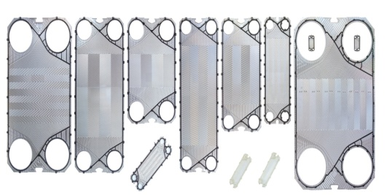
Distance Ring(Metal+Rubber) Rubber Spool Blind Pad
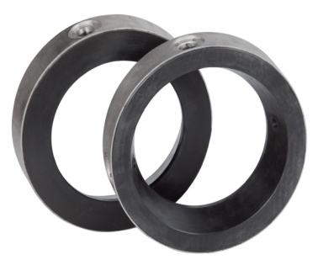
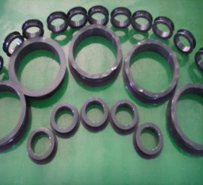
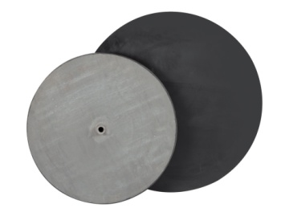
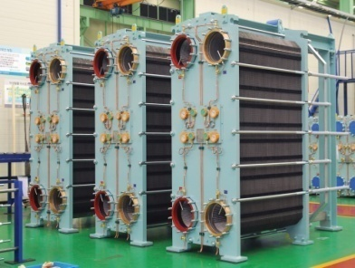

㈜바이저
대표자 | 송미란 | 설립일 | 2004년 4월 9일
휴대전화번호 | 010.5514.4599 | 업종 | 제조
전화번호 | 070.8611.3260 | 팩스번호 | 055.346.0841
E-Mail | smr@viser.co.kr | Homepage | www.viser.co.kr
주 소 | 621-873 경남 김해시 한림면 신천리 431-1번지
주요생산품 | - 판형열교환기 가스켓 ( 최대가스켓size : 37,000mm(L)*1,400mm(W) )  - 금속부속방지를 위한 고무라이닝  -Distance ring /Rubber spool / Blind pad  - 특수목적용고무 (고객 맞춤형 조선산업용 고무제품 외 다수)  - 각종 판형열교환기에 부착되는 가스켓 및 국내•외의 타사 판형열교환기 제품에 부착되는 가스켓 A/S  - 당사는 모든 종류의 판형열교환기가스켓을 생산할 수 있습니다. 또한 당사에서는 고객의 현재 사용 열교환기가스켓이 국내•외 타사의 제품인 경우라도 최선의 A/S를 제공합니다.  - 취급재질- NBR, EPDM, Silicone, IIR, FPM(=FKM), PTFE, H-NBR, NR, SBR, CR 외 다수
제품사진
- 판형열교환기 가스켓

- 금속부속방지를 위한 고무라이닝

Distance Ring(Metal+Rubber) Rubber Spool Blind Pad

SHINSEUNG PRECISION INDUSTRY LTD.
C.E.O | Kim Myung Han |  | Established |  | 1990. 05
Mobile phone | +82-10-874-1225 |  | Types of business |  | Manufacture
TEL | +82-55-255-8936~7 |  | FAX |  | +82-55-255-935
E-Mail | shinseung@kssp.co.kr |  | Homepage |  | http://kssp.co.kr
Address | 48-4 Ungnam-dong Changwon, Gyeongnam 641-290 S.Korea
Product | Aerospace & Satellite Parts, National defense Parts,  Digital machinery & Tools
(Product photo)
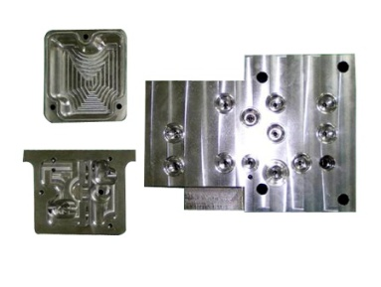 |  | 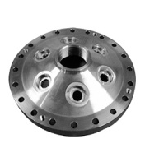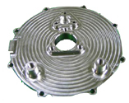  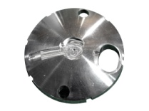 |  | 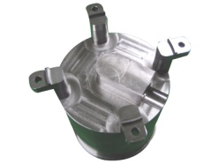  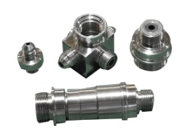
National defense Parts  /Case & Valve Body |  | National defense Parts /Nozzle Array Structure, End, Cover Cap |  | National defense Parts / artificial satellite part
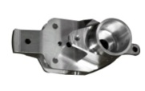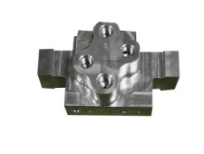  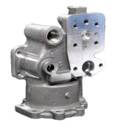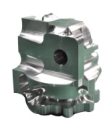 |  | 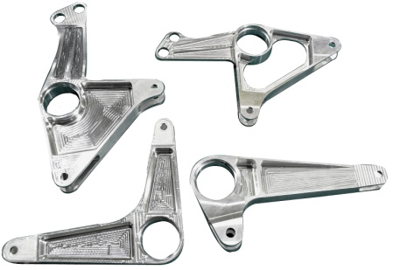 |  | 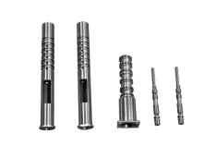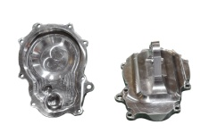  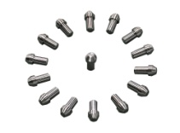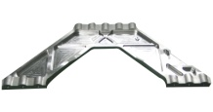
Aerospace part /  Valve, Housing |  | Aerospace part /Crank |  | Aerospace part/Spool, Sleeve Housing earth, Peg
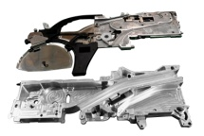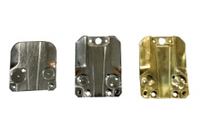  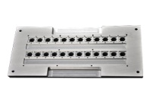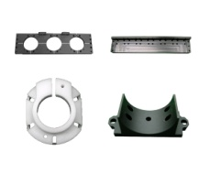 |  | 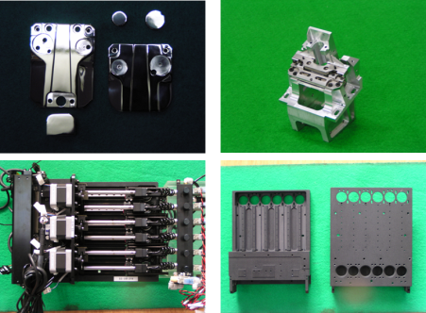 |  | 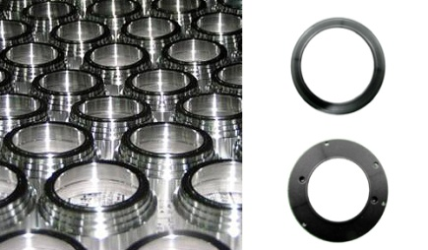
Digital machinery / Wire Bonder, Chip Mount, PLATE |  | Wire Bonder part |  | Digital machinery /Adapter

Company Name ( )
President |  |  | Establishment
Cellular Phone |  |  | Business Type
Tel. |  |  | Fax.
E-Mail |  |  | Homepage
Address
Main
Product
(Products Potograph)

회사명( )
대표자 |  |  | 설립일
휴대전화번호 |  |  | 업종
전화번호 |  |  | 팩스번호
E-Mail |  |  | Homepage
주 소
주요생산품
(제품사진)
사진
제품명

